**Design Thinking (phase 2)**

**Critical Issues**

Critical issues help prioritize the pains and gains of the customer empathy map(s). Select from the pains and gains those issues that are particularly important for your customers. That's it :-)!

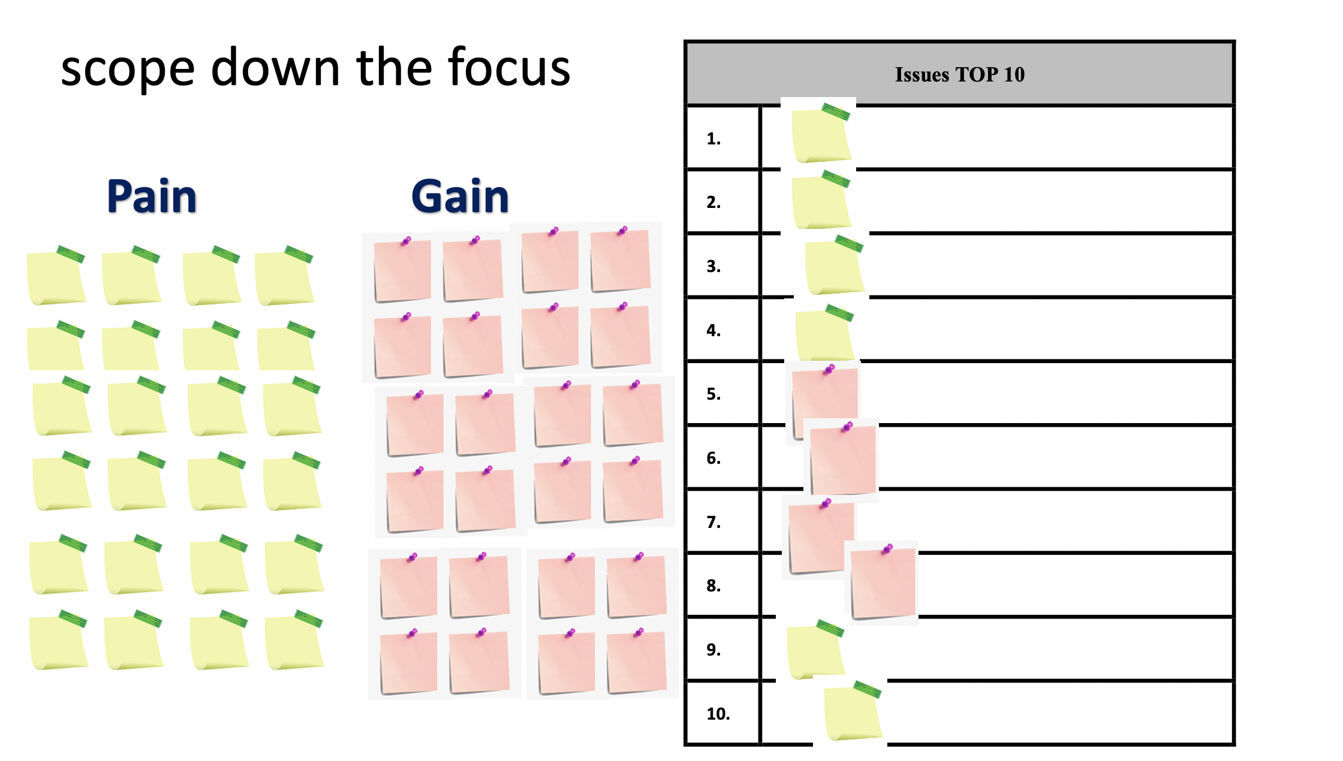

**How might we**

The identified critical issues can be transferred into HMW questions. By asking questions, brainstorming sessions on possible solutions can be more fruitful.

The How Might We Method is a (proven) design thinking activity which has participants simply rephrase known challenges as a question beginning with “How Might We”.

A How might we (HMW) question can generate lots of creative ideas. Here are some examples of How might we questions:

* How might we ensure more people pay their taxes before the deadline?
* How might we help employees stay productive and healthy when working from home?
* How might we make customers feel that their information is safe and secure when creating an account?

<https://www.youtube.com/watch?v=YwkrpBeuJms>

https://www.youtube.com/watch?v=XUW78qyyObE